**OVERVIEW**

**PROBLEM STATEMENT:**

***Description:***

Many educational institutions struggle with outdated and inefficient course registration systems, leading to frustration among students, faculty, and administrative staff. These systems often lack user-friendly interfaces, causing confusion and errors during the registration process. Additionally, they may lack real-time updates, making it difficult for students to access accurate course information and availability. Moreover, the absence of personalized course suggestions based on students' interests and academic requirements further exacerbates the problem.

***Problem:***

The current online course registration system suffers from several shortcomings:

***Lack of user-friendliness:*** The interface is complex and unintuitive, leading to confusion and errors during the registration process.

***Limited accessibility:*** The system may not be accessible from all devices, hindering students' ability to register for courses remotely.

***Inaccurate information***: The system may not provide real-time updates on course availability, leading to students enrolling in filled or canceled courses.

***Poor scalability:*** As student populations grow, the system may struggle to handle increased traffic, resulting in slowdowns or crashes during peak registration periods.

***Absence of personalized course suggestions:*** The system does not offer tailored course recommendations based on students' academic interests, goals, and requirements.

***Objective:***

The objective is to develop an efficient and user-friendly online course registration system that addresses the aforementioned shortcomings. This system should:

* Provide a seamless and intuitive user interface for students, faculty, and administrative staff.
* Ensure accessibility across multiple devices and platforms to facilitate remote registration.
* Offer real-time updates on course availability and scheduling to prevent enrollment errors.
* Scale effectively to accommodate growing student populations and peak registration periods.
* Implement a personalized course suggestion feature that recommends relevant courses based on students' interests, academic history, and degree requirements.

This project aims to enhance the overall registration experience for all stakeholders by providing a comprehensive and efficient course registration system with personalized course suggestions, thereby improving student satisfaction and academic outcomes within the educational institution.

**PROPOSED SOLUTION:**

The proposed solution involves the development and implementation of an integrated online course registration system that incorporates advanced features such as user-friendly interface design, real-time updates, scalability optimization, and personalized course recommendation functionality. This solution aims to streamline the course registration process for students, faculty, and administrative staff while addressing the challenges identified in the problem statement.

***How it Addresses the Problem:***

***User-Friendly Interface Design:***

The new system will feature a redesigned user interface with intuitive navigation, clear instructions, and visually appealing design elements. This addresses the problem of user-friendliness by making it easier for students, faculty, and staff to navigate the registration process without encountering confusion or errors.

***Real-Time Updates and Automation:***

By integrating real-time data synchronization mechanisms with the institution's course management systems, the new system ensures that course availability information is accurate and up-to-date. Automated notifications will alert students and faculty about changes in course status, enrollment deadlines, and academic calendar updates, mitigating the problem of inaccurate information and reducing manual administrative tasks.

***Enhanced Accessibility:***

The system will utilize responsive web design techniques and cloud-based infrastructure to ensure accessibility from various devices, including smartphones, tablets, and desktop computers. This addresses accessibility issues, enabling students to register for courses remotely with ease, even during peak registration periods.

***Scalability Planning and Optimization:***

Through capacity planning exercises and infrastructure scaling strategies, the new system will be optimized to handle increased traffic during peak registration periods without compromising performance. This ensures system scalability and reliability, addressing concerns about system slowdowns or crashes during high-demand periods.

***Personalized Course Recommendation Engine:***

A machine learning-based recommendation engine will analyze students' academic histories, interests, and career aspirations to generate personalized course recommendations. These recommendations will be validated by academic advisors and faculty members, providing students with tailored course suggestions that align with their goals and interests.

***Benefits:***

***Improved User Experience:***

The user-friendly interface and streamlined registration process enhance the overall user experience for students, faculty, and administrative staff, reducing frustration and errors.

***Accurate and Up-to-Date Information:***

Real-time updates and automated notifications ensure that students have access to accurate course availability information, reducing the likelihood of enrolling in filled or canceled courses.

***Enhanced Accessibility and Flexibility:***

Responsive design and cloud-based infrastructure make the system accessible from various devices, enabling students to register for courses remotely with ease.

***Scalability and Reliability:***

Scalability optimization measures ensure that the system can handle increased traffic during peak registration periods without experiencing performance issues, enhancing system reliability.

***Personalized Learning Experience:***

The personalized course recommendation engine provides students with tailored course suggestions that align with their academic interests and career goals, promoting a more personalized learning experience and improving student satisfaction and retention rates.

**BUSINESS ARCHITECTURE:**

Business architecture in software engineering is the structural framework that aligns technological solutions with business objectives. It provides a blueprint for integrating business processes, information flows, and organizational structures within software systems. This discipline involves mapping business requirements to software solutions to ensure that technology investments support strategic goals effectively. Key components include analyzing and optimizing business processes, defining information architecture for data storage and flow, designing systems for enterprise integration, understanding organizational structure for effective collaboration, and determining technology infrastructure requirements. By focusing on these areas, organizations can drive innovation, improve operational efficiency, and gain competitive advantages through their software solutions.

**PROPOSED SYSTEM:**

A proposed system in software engineering outlines a new software solution's conceptual design, tailored to meet specific organizational needs or challenges. It represents an evolution of the current system, incorporating enhancements or new features to address updated requirements or seize emerging opportunities. This blueprint serves as a roadmap for development teams, detailing key features, functionalities, and architecture. It involves thorough requirements analysis to identify user needs and business objectives, followed by system design to define the software's structure and components. Prototyping allows stakeholders to visualize the system and provide feedback, while feasibility studies assess its technical, economic, and operational viability within existing constraints. Risk management strategies identify and mitigate potential obstacles. By articulating a comprehensive proposed system, software engineering teams ensure alignment with organizational goals, streamline development processes, and deliver solutions that effectively meet user expectations, fostering innovation and competitive advantage.

**BUSINESS ARCHITECTURE DIAGRAM:**

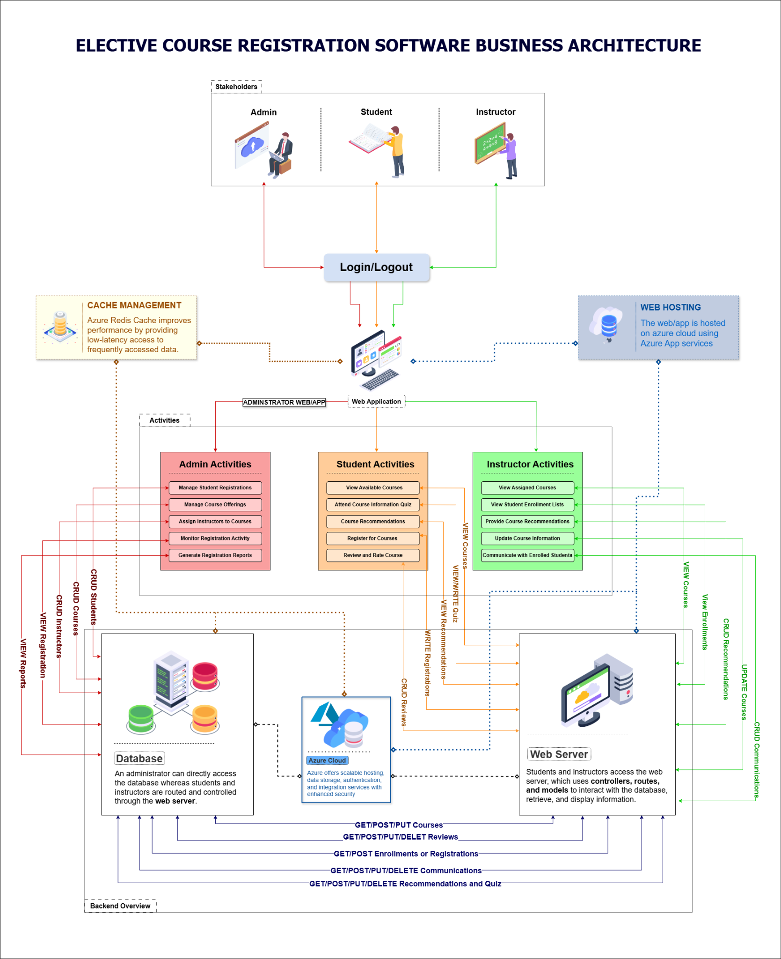

**USER STORIES AND AGILE SCRUM :**

**USER STORIES:**

***As a Student:***

1. *Browsing and Searching Courses:*

- As a student, I want to browse a list of available elective courses so that I can explore my options for the upcoming semester.

- As a student, I want to search for courses by keywords, course codes, or instructor names so that I can quickly find specific electives.

2. *Reading Course Descriptions:*

- As a student, I want to read short descriptions of each elective course so that I can understand the course objectives and content.

3. Favoriting and Comparing Courses:

- As a student, I want to mark courses as favorites so that I can easily refer back to them later.

- As a student, I want to compare up to three courses side-by-side so that I can make an informed decision on which elective to choose.

4. Checking Schedule Compatibility:

- As a student, I want to see how my selected courses fit into my existing schedule so that I can avoid time conflicts.

5. Enrolling in Courses:

- As a student, I want to easily enroll in my selected courses through the application so that I can secure my spot without additional steps.

***As a College Administrator***

1. *Managing Course Listings:*

- As a college administrator, I want to manage the list of available elective courses so that I can ensure the offerings are up-to-date and accurate.

2. *Monitoring Enrollment Trends:*

- As a college administrator, I want to monitor enrollment trends and popular courses so that I can make data-driven decisions about future course offerings.

3. *Handling Prerequisites and Conflicts:*

- As a college administrator, I want to ensure that students are informed about prerequisites and potential scheduling conflicts so that they can make suitable choices.

4. *Facilitating Registration Integration*:

- As a college administrator, I want to integrate the application with the college’s registration system so that the enrollment process is seamless for students.

5. Collecting Student Feedback:

- As a college administrator, I want to collect and analyze student feedback on c

***As a Faculty Member***

1. *Creating and Updating Course Information:*

- As a faculty member, I want to create and update the information for the courses I teach so that students have accurate and comprehensive details.

2. *Monitoring Enrollment Numbers:*

- As a faculty member, I want to monitor the enrollment numbers for my courses so that I can anticipate class size and prepare accordingly.

3. *Receiving Student Feedback:*

- As a faculty member, I want to read reviews and feedback from students about my courses so that I can understand their experiences and make improvements.

4. *Communicating with Students:*

- As a faculty member, I want to communicate with students who have enrolled in my courses so that I can provide updates and important information prior to the semester starting.

5. *Reviewing Enrollment Prerequisites:*

- As a faculty member, I want to review the prerequisites for my courses to ensure that enrolled students meet the necessary requirements.

By addressing these user stories, the Elective Course Selection Application will cater to the needs of students, administrators, and faculty members, providing a comprehensive and efficient solution for elective course management.

**POKER PLANNING:**

**NON FUNCTIONAL REQUIREMENTS:**

* As a user , I am able to access the software easily. [within seconds]
* As a user, I can navigate to pages easily.
* As a user, my data will be put into the secured database.
* As a user, the system recovery will be within a few seconds.
* As a student, I am able to get the list of all services on the dashboard.

**ARCHITECTURAL DIAGRAM:**

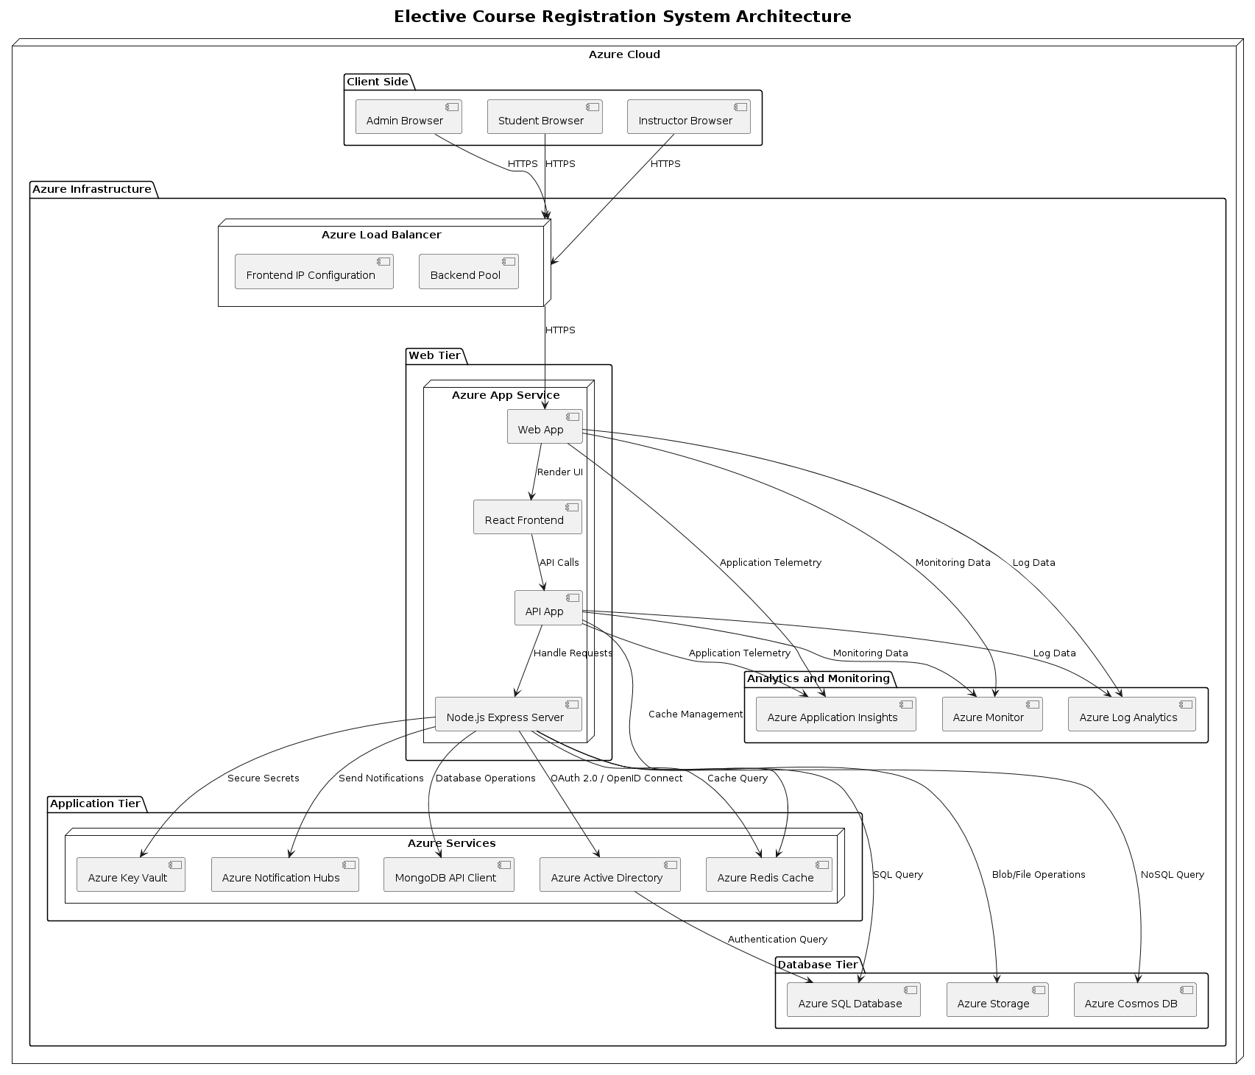

**MVC ARCHITECTURAL DIAGRAM:**

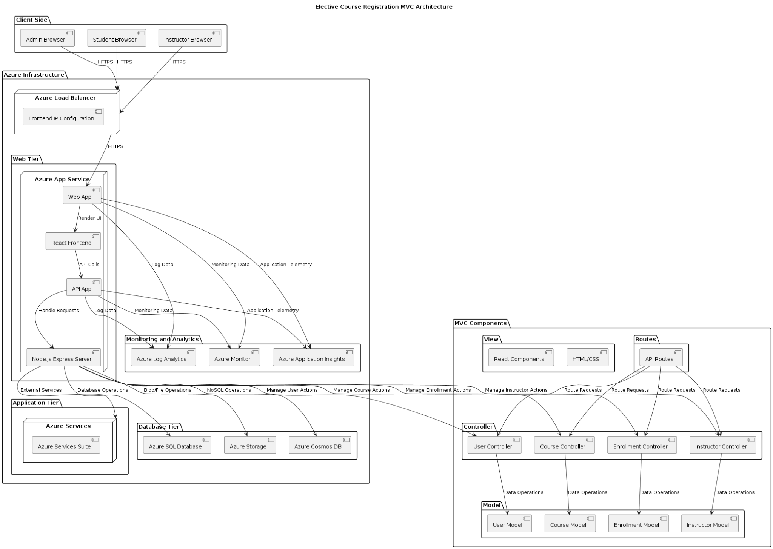

**USE CASE DIAGRAM:**

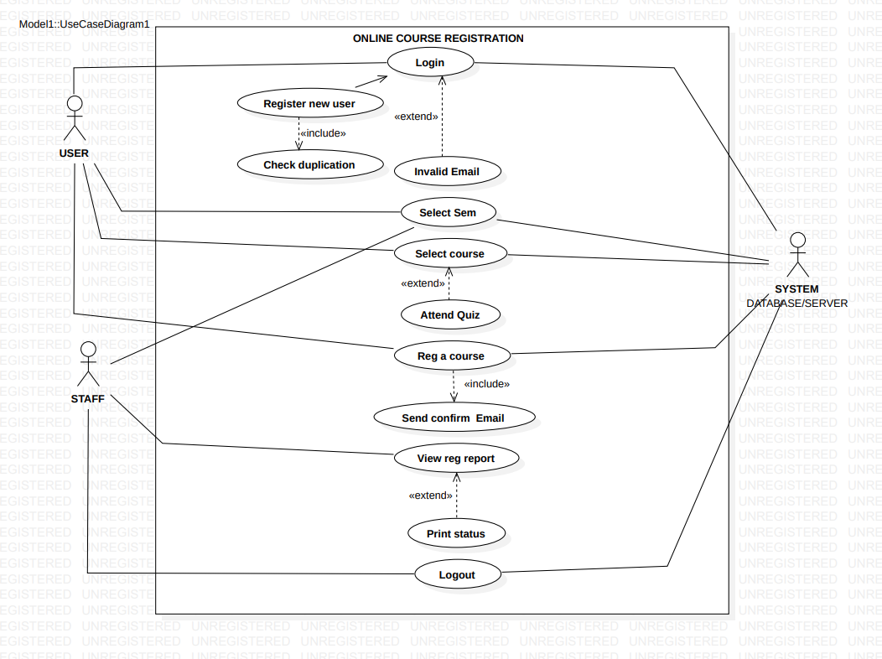

**DESIGN PRINCIPLES:**

**CLASS DIAGRAM:**

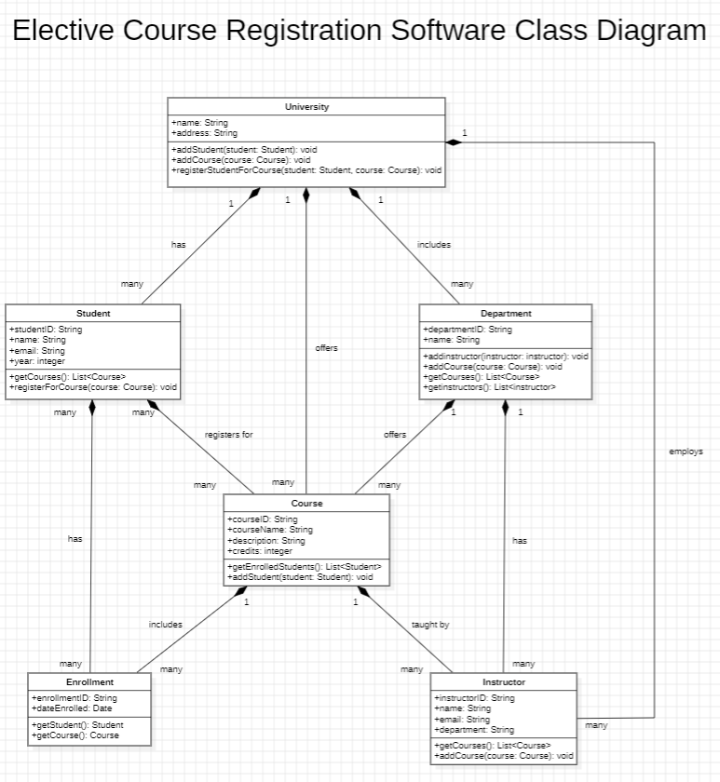

**SEQUENCE DIAGRAM:**

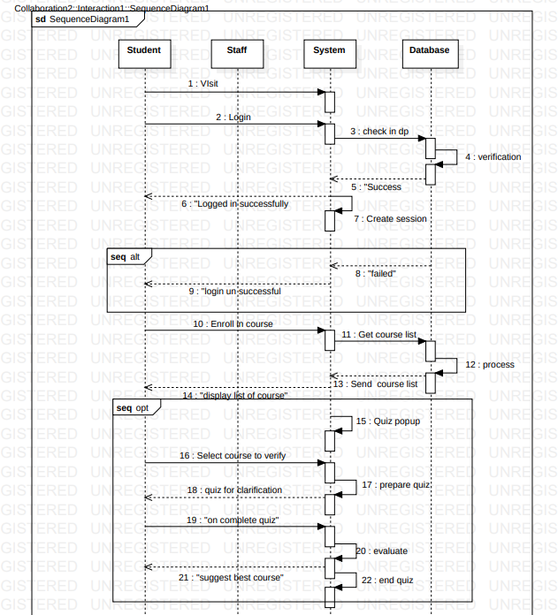

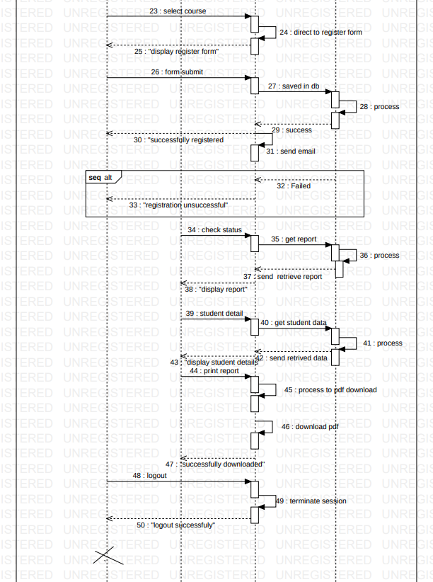

**TEST STRATEGY:**

**TEST CASES:**

**DEPLOYMENT ARCHITECTURE:**

**AZURE DEPLOYMENT DIAGRAM:**

